Uniform Distribution:

Types:

1. Continuous Uniform distribution (pdf)

2. Discrete Uniform distribution (pmf)

Continuous uniform distribution: (For continuous random variable)

Definition: In probability theory and statistics, the continuous uniform distributions or rectangular distributions are a family of symmetric probability distributions. Such a distribution describes an experiment where there is an arbitrary outcome that lies between certain bounds. The bounds are defined by the parameters, a and b which are the minimum and maximum values.

Notation: U(a,b)

Parameters: -∞ < a < b < ∞

Pdf = $\left\{\begin{aligned}\frac{1}{b-a} if x ∈[a,b] \\ 0 otherwise\end{aligned}\right.$

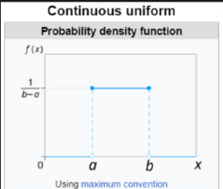

Cdf = $\left\{\begin{aligned}0 for x<a \\ \frac{x-a}{b-a} for x ∈[a,b] \\ 1 for x>b\end{aligned}\right.$

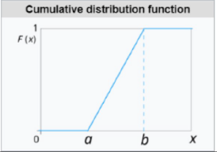

Mean = ½ (a+b)

Median = ½ (a+b)

Variance = $\frac{1}{12}$ (${b-a)}^{2}$

Example:

Q: The number of candies sold daily at a shop is uniformly distributed with a maximum of 40 candies and a minimum of 10 candies.

i) Probability of daily sales to fall between 15 and 30

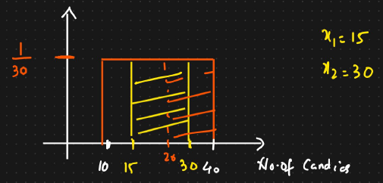

In order to calculate this, we will define two variables

Pr(15 $≤x≤30$) = (x2-x1) $\frac{1}{b-a}$\* = 15 \* 1/30 = 0.5

ii) Probability of daily sales to be greater than 20 candies

Pr(20 $≤x≤40$) = (x2-x1) $\frac{1}{b-a}$\* = 20 \* 1/30 = 0.66

Discrete Uniform distribution: (For discrete random variable) -> PMF is used

Definition: In probability theory and statistics, the discrete uniform distribution is a symmetric probability distribution wherein a finite number of values are equally likely to be observed; every one of n values has equal probability 1/n. Another way of saying “discrete uniform distribution” would be “a known, finite number of outcomes equally likely to happen”.

Eg: Rolling a dice, each outcome has equal probability

n = b-a + 1 = 6-1 + 1 = 6

Notation: U(a,b)

Parameters: a,b where b $≥$ a

PMF = 1/n

Mean = Median = ½ (a+b)

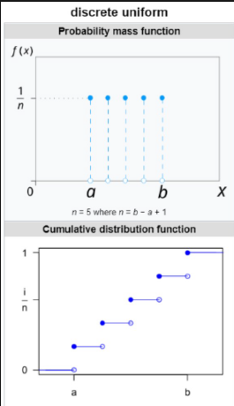

We get this cumulative distribution, by adding each probability.